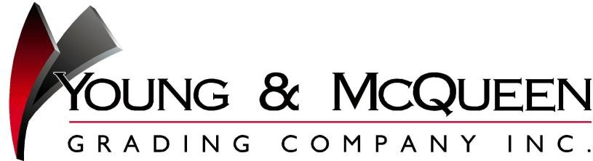

November 23, 2015

Prospective Subcontractors and Suppliers
Attn: Estimating Department

RE: Invitation to bid
NCDOT Letting: December 15, 2015

To Whom It May Concern,

Young & McQueen Grading is currently accepting bids for the project(s) listed below from DBE/MBE/WBE certified contractors and suppliers for all materials and the following scopes of work, if applicable: hauling, demolition, erosion control, seeding, storm drainage, asphalt, guardrail, signage, striping, structures, clearing & grubbing, curb & gutter, and surveying.

Please fill in your company information, indicate your intent to bid, your scope(s) of interest, and return this solicitation via fax to
828-682-9286 or email to atipton@youngmcqueen.com, by no later than noon on December14, 2015.
We request that you please return this form so we will know your intent to bid. Please advise if you do not wish to be solicited in the future.
Certified NCDOT Vendor Type:
Contractor’s Name:
Contractor’s Contact Person:
Contact Person’s Phone Number:
Scope of Work Bidding:

❑ MBE
❑ WBE
❑ DBE

Contract Number County WILL Bid NOT Bid
C203498 Jackson County (Grading, Drainage, Paving, Signals
and Structure)

C202582 Transylvania County (Grading, Drainage, Paving,
and Retaining Walls)

All Subcontractor/ Supplier Bids are due by 12:00 PM on December 14th, 2015. Please email to atipton@youngmcqueen.com or fax to 828-682-9286.

All project item lists, specifications and plans are available in .pdf format at:
http://ncdot.org/doh/preconstruct/ps/contracts/letting.html or can be viewed at our office, at the address below.

Young & McQueen will consider a reasonable request for assistance from contractors for equipment, supplies and other items necessary to perform work and also extend an offer of assistance in regards to areas of bonding, line of credit, insurance, etc. We will also consider breaking work out into economically feasible units. Please call to discuss any requests you may have prior to bid. Should you have questions regarding this project please call 828-682-7714 ext. 40. Thank you!

Young & McQueen Grading Co., Inc. is an Equal Opportunity Employer, and complies with ALL FHWA-1273 requirements.

25 Crest View Road Burnsville, NC 28714
Phone 828-682-7714 1-800-211-4567 Fax 828-682-4145 www.youngmcqueen.com
NC License# 27438

Subcontractor Work Opportunities
Include, but are not limited to the following:

❑ Construction Surveying
❑ Clearing and Grubbing
❑ Demolition
❑ Rock Drilling and Blasting
❑ Hauling (unclassified materials, stone items, and waste material)
❑ Asphalt Removal
❑ Temporary Shoring
❑ Storm Drainage (pipe, boxes, and castings)
❑ Asphalt (base, intermediate, surface, and patching)
❑ Milling Asphalt Pavement
❑ Curb and Gutter (driveways, ditches, and islands)
❑ Precast Barrier Wall
❑ Guardrail and Fencing (guardrail, end units, woven wire fence, and chain link fence)
❑ Signage (temporary and permeant)
❑ Temporary Barrier Wall and Impact Attenuators
❑ Pavement Markings (paint, polyuria and snow plow-able markers)
❑ Seeding and Mulching (matting, wattles, PAM, mowing, reforestation and aerial topdressing)
❑ Erosion Control (silt/safety fence, baffles, wattles and stream mitigation)

Please list any additional services that may be provided for this project in the spaces below:

